**Smartphone separation anxiety: How bad is your nomophobia?**

**Today, Meghan Holohan, May 14, 2015**

[**http://www.today.com/health/smartphone-separation-anxiety-how-bad-yours-t20786**](http://www.today.com/health/smartphone-separation-anxiety-how-bad-yours-t20786)

**How nomophobic are you?**

(Note: The instrument below was developed by: Caglar Yildirim, Iowa State University, Human Computer Interaction program, and Ana-Paula Correia, Associate Professor, School of Education, Iowa State University;

Citation: Yildirim, C. & Correia, A.-P (2015). Exploring the Dimensions of Nomophobia: Development and Validation of a Self-Reported Questionnaire. *Computers in Human Behavior, 49*(August 2015), 130-137. DOI: 10.1016/j.chb.2015.02.059)

Determine your level by answering each of the following questions on a scale from one to seven, where one is strongly disagree and seven is strongly agree. Score yourself by adding up the numbers: the higher the number, the more severe your nomophobia.

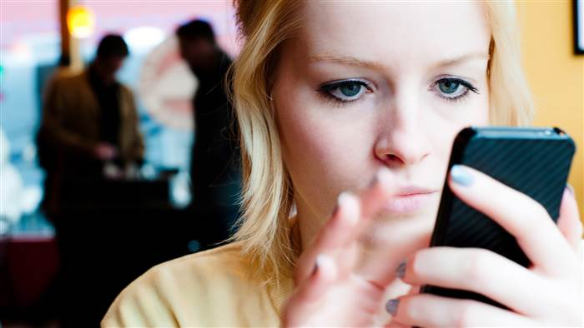

**Questions (1 = strongly disagree; 7 = strongly agree):**

1. ___ I would feel uncomfortable without constant access to information through my smartphone.
2. ___ I would be annoyed if I could not look information up on my smartphone when I wanted to do so.
3. ___ Being unable to get the news (e.g., happenings, weather, etc.) on my smartphone would make me nervous.
4. ___ I would be annoyed if I could not use my smartphone and/or its capabilities when I wanted to do so.
5. ___ Running out of battery in my smartphone would scare me.
6. ___ If I were to run out of credits or hit my monthly data limit, I would panic.
7. ___ If I did not have a data signal or could not connect to Wi-Fi, then I would constantly check to see if I had a signal or could find a Wi-Fi network.
8. ___ If I could not use my smartphone, I would be afraid of getting stranded somewhere.
9. ___ If I could not check my smartphone for a while, I would feel a desire to check it.

**If I did not have my smartphone with me (1 = strongly disagree; 7 = strongly agree):**

1. ___ I would feel anxious because I could not instantly communicate with my family and/or friends.
2. ___ I would be worried because my family and/or friends could not reach me.
3. ___ I would feel nervous because I would not be able to receive text messages and calls.
4. ___ I would be anxious because I could not keep in touch with my family and/or friends.
5. ___ I would be nervous because I could not know if someone had tried to get a hold of me.
6. ___ I would feel anxious because my constant connection to my family and friends would be broken.
7. ___ I would be nervous because I would be disconnected from my online identity.
8. ___ I would be uncomfortable because I could not stay up-to-date with social media and online networks.
9. ___ I would feel awkward because I could not check my notifications for updates from my connections and online networks.
10. ___ I would feel anxious because I could not check my email messages.
11. ___ I would feel weird because I would not know what to do.

**___ Total Score**