Documenting Life Change from Open Educational Resources, OpenCourseWare, and Participation and Massive Open Online Courses

AECT Roundtable paper, October 31, 2013, Thursday 2:15-3:15 pm

1st Level South Royal Ballroom C/D

Curtis J. Bonk, Indiana University

Mimi Miyoung Lee, University of Houston

Xiaojing Kou, Indiana University

Feng-Ru Sheu, National Sun Yat-Sen University, Kaohsiung City, Taiwan,

Abstract. There are an endless array of open educational resources (OER), open courseware (OCW), and massive open online courses (MOOCs) available for self-directed learning pursuits. This study explores the learning experiences, including the barriers, obstacles, motivations, and successes of directed online learners. In particular, it focuses on the types and forms of life change experienced by people around the world who employ OCW and OER. Data collection included a 43-item survey of 1,429 newsletter subscribers of the MIT OCW initiative. This is a mixed methods design. The researchers qualitatively analyzed emerging themes from open-ended survey items as well as the descriptive statistics from the closed-ended items. The findings help capture informal and self-directed learning experiences through informal education channels, including OCW, OER, and MOOCs. Documenting life changes from informal learning from open ended content can hopefully serve to inspire others.

Documenting Life Change from Open Educational Resources, OpenCourseWare, and Participation in Massive Open Online Courses

Curtis J. Bonk, Indiana University

Mimi Miyoung Lee, University of Houston

Xiaojing Kou, Indiana University

Feng-Ru Sheu, National Sun Yat-Sen University, Kaohsiung City, Taiwan,

Introduction
Wendy Ermold, a researcher and field technician for the University of Washington Polar Science Center conducts research in remote northern regions of the world (Bonk, 2009). Wendy informed us that when out on the icebreakers or remote islands, she listens to lectures and reviews various open educational resources (OER) she has found. Such content often comes from MIT OpenCourseWare (OCW) as well as from Stanford, Seattle Pacific University, and Missouri State University. Each is used to update her knowledge of physics and other content areas. As such free and open educational resources expand, learning becomes increasingly personalized and catered to a particular learning need or learner preference.
Hundreds of millions of people like Wendy are now learning using some online tool, resource, or activity each day. The Web offers new hope for a hobby, degree, or personal lifelong learning dream. Unfortunately, there are few if any research projects documenting the opportunities of OER, OpenCourseWare (OCW), and massive open online courses (MOOCs) (Iiyoshi & Kumar, 2008). There is a need to capture case studies of individuals whose lives have been altered or significantly changed from casual informal as well as more extreme learning or teaching pursuits. Are there empowerment moments that can be captured, demonstrated, explained, and perhaps replicated or extended? This paper documents moments in informal online learning wherein different people experienced an “empowerment moment” or key event that changed their lives in a modest or more significant way as a result of learning with technology. By cataloguing hundreds of ways in which informal and nontraditional Web-based learning have impacted people across ages, gender, ethnicities, and cultures, we hope to inspire others to continue to learn across the lifespan.

The OpenCourseWare (OCW) Initiative
On April 4, 2001, Charles Vest, then president of MIT, made an historic announcement. He set a goal of having most of his university’s courses freely available on the Web in a decade. While some thought this to be a rather bold proclamation, by the early part of 2009, MIT had its entire curriculum of 1,800 courses online. MIT beat its original target by more than 3 years. Today, all of their courses remain available for self-directed learners around the globe to explore, download, use, and share. And they are continually updated, enhanced, and expanded upon. Anyone with an Internet connection can read, watch, or listen to these resources.
Vest had thought that the Council on Educational Technology that he had assigned to investigate online learning and opportunities outside classroom walls would come up with new revenue models. He did not envision that he would be giving away his contents on the Web. At the same time, he thought that the OpenCourseWare (OCW) project would be highly innovative and help advance education by widening access to it and inspiring other institutions of higher learning to also participate. As Vest noted,
This is about something bigger than MIT. I hope other universities will see us as educational leaders in this arena, and we very much hope that OpenCourseWare will draw other universities to do the same. We would be delighted if -- over time -- we have a world wide web of knowledge that raises the quality of learning -- and ultimately, the quality of life -- around the globe.
Vest viewed the OCW initiative as one that embraced ideas related to the openness of education as well as outreach to underserved populations as well as for retirees and others to learn new hobbies. Learners could draw upon these materials for self-study. At the same time, instructors could share contents through OCW types of projects on other campuses around the world. With more than 1 million visitors to the OCW website each month and another 500,000 for translated versions of the content, there is no doubt that Vest was correct in assuming that there was a population interested in such content.
Soon the OCW consortium was formed with over 250 other universities and associated organizations from Japan, Taiwan, China, Spain, Korea, Mexico, the Netherlands, and part of Africa as well as universities in the United States such as Tufts University, the University of Michigan, Johns Hopkins University, and the University of California, Irvine. Combined, these higher education institutions have made available more than 13,000 materials in 20 languages. MIT materials are available in English as well as in Spanish, French, Persian, Turkish, Korean, Thai, Portuguese, and Chinese.

Emergence of Open Educational Resources (OER)
Not only are thousands of these open courses available for self-directed study, but countless open portals are rich in educational content for self-discovery and informal learning as well as for more formal class activities. Free and open learning portals exist on most major figures in history including William Shakespeare, Jane Austin, Albert Einstein, Maria Montessori, and Winston Churchill. Some portals such as YouTube, TED, Academic Earth, and LinkTV exist are devoted to indexing shared online video (Bonk, 2011). Such portals are considered part of the open educational resource (OER) movement. As a new movement, there remains much to resolve when developing, sharing, or using OER; especially concerns about resource preservation, the sustainability of the content, intellectual property rights, content quality and enhancement, and measuring the impact of its use (Atkins, Brown, & Hammond, 2007; Downes, 2007).
OER is widespread not only in higher education settings, it has also emerged as a significant aspect of K-12 education. In fact, legislation is now pending for $500 million for grants to states and school districts for different aspects of educational technology, including online learning as well as the use of OER for improving efficiency and productivity (Stansbury, 2013). Along these same lines, the Obama administration is working on plans to provide public access to federally funded research (Rivard, 2013). In response, the Association of American Publishers has announced a novel project known as the Clearninghouse for the Open Research of the United States (CHORUS) that would free up peer-reviewed journal articles following a one year embargo (Rivard, 2013). Suffice to say, OER and open access to research is receiving much attention and funding the past several years. This raised awareness for OER is bound to lead to vast increases in informal as well as formal learners using such free and open materials.

The Need for Self-directed Learning
Online learning and free and open contents have also transformed life for adult learners. For instance, through OCW, OER, and now MOOCs, those stuck behind prison walls, injured and in a hospital bed, or unemployed and unable to pay for college tuition can learn to be more productive members of society. Others might be in transition from one career to another and find OER and OCW can arouse new interests and confidence (Iiyoshi & Kumar, 2008). Still others might be enrolling in open courses while in war zones in Iraq or Afghanistan (Kenning, 2012; Millard, 2011). If they are transferred, they can continue their education at their new base location.

Informal and Extreme Learning Website Analysis and Survey Construction
A list of over 300 informal and extreme learning Web sites was created by a team of researchers based on a thorough literature review as well as recommendations from soliciting experts recommendations, blog post reviews, and scanning other online resources (Jung, Kim, Wang, & Bonk, 2011). These Web resources included those related to language learning, adventure learning, social change/global education, virtual education, learning portals, and shared online video. A subteam of four individuals from the main team evaluated these sites using an eight-part coding scheme over a six month period (Jung, et al., 2011). The Website evaluation criteria included aspects of the following: content richness, functionality of the technology, novelty (both technological and pedagogical), scalability, learning as well as life change potential, and extent of technology integration.
During the year evaluating hundreds of informal and extreme learning Websites, the researchers noted the diversity of informal learning experiences, range of skills or competencies emphasized, different delivery mechanisms and technologies utilized, motivational techniques employed, and potential barriers or obstacles to their use. Using this insight, a 43-item survey was designed using SurveyShare, a Web-based survey hosting service. The survey was intended to understand self-directed learning from such free and open online environments; including the collection of life changing stories. Items were refined, expanded, clarified, and, at times, deleted. Definitions of both informal learning as well as extreme learning were also crafted and inserted into the survey.
The close-ended portion of the survey inquired into many aspects of informal learning. Such areas included the goals one wished to accomplish through informal learning pursuits and activities (e.g., high scores, new friends, personal freedom, enhanced self-worth, etc.), reasons for exploring Web resources informally (e.g., curiosity, interest, professional growth, hobbies, goals for self-improvement, etc.), factors leading to success (e.g., choice, collaboration, identity, advice from others, sense of adventure, producing or creating something, etc.), what they would like to learn (e.g., a foreign language, artistic skills, environmental information, music skills, etc.), and typical barriers or obstacles faced when learning informally on the Web (e.g., lack of excitement, lack of time, technical problems, lack of quality resources, etc.). We also asked a question about what they would like to achieve (e.g., learn how to fix something, course credit, learn something that can be used to help others, etc.).
In addition to the initial 25 close-ended questions, respondents had the option to complete 15 open-ended questions that asked about their informal learning experience (See Appendix A for details on the “Open Ended Survey Questions”).
The survey was piloted internally and then externally. After such pilot testing, a survey was conducted of two different populations of self-directed learners.

Open-Ended Survey Questions
The open ended questions included those related to goals and aspirations using OER, OCW, and MOOCs. Participants were also asked about their most interesting and successful informal learning experiences and what they accomplished. In addition, they were asked how this activity was unusual, interesting, or different from ways in which they typically learn. Another open-ended item concerned suggestions that they might have for others wanting to learn informally with OER, OCW, and other Web resources and technologies.
Other open-ended items included those related to the informal learning influences and supports that they received. For instance, did they have any role models, mentors, tutors, or other aids? Also, how might friends and family members play a role in using OER? In terms of challenges or obstacles that they faced, what were the solutions that they came up with? The researchers also inquired into the different forms and types of technology that facilitated their learning when in informal and more extreme environments. Finally, the goals of future open education and associated technologies for their online success were explored. Key findings from the MIT OCW dataset will be briefly described below followed by some of the qualitative results for the Blackboard MOOC data.

Population

As detailed below, the research data was collected in August 2012 through a Web-based survey of two large online learning communities. Both communities were related to the use of OER and open course materials. The open-ended responses are the primary focus of this study. As a mixed methods study, these open-ended findings are supplemented by several quantitative results.

In terms of the second population, the sample was derived from subscribers to the e-newsletter related to the popular MIT OpenCourseWare (OCW) initiative. At the time, the newsletter subscription list had more than 156,000 active subscribers, of which, some 41% were described as self-learners, 40% students, 15% educators, and 3% parents. About 26,700 people opened the email and 4,000 people clicked through to the survey. Some 1,429 people completed the survey, including 613 people who completed one or all of the survey items. About half of the respondents were age 40 or younger. The half that was over age 40 included 64 respondents over age 70; roughly 5 percent of the MIT OCW sample pool. In contrast to the Blackboard survey, most in the MIT sample were males (76%). Significantly fewer were from North America (618 people; 44 percent). Large numbers of respondents came from Asia (331 people; 23 percent), Europe (202 people; 14 percent), and South America (133 people; almost 10 percent). Among the top countries represented in the MIT OCW subscriber list were the United States, India, China, Brazil, Nigeria, Pakistan, Iran, Canada, the UK, Taiwan, Indonesia, Mexico, and Egypt.

The survey took around 15 to 20 minutes to complete. Our data analysis here focuses primarily on the purposes and goals as well as obstacles and challenges that these self-directed learners encountered while learning through informal educational channels of open educational resources and MOOCs. For the purposes of this study, the qualitative data from relevant open-ended questions will be analyzed by a team of qualitative researchers with QSR NVivo for coding to enable the identification of themes and comparisons across such themes. Where appropriate, findings from the closed ended items supplemented the qualitative results. The next step in this research will be interviews and focus groups of some of the respondents identified in the qualitative analysis process.

Open-Ended Survey Questions
The open ended questions included those related to goals and aspirations using OER, OCW, and MOOCs. Participants were also asked about their most interesting and successful informal learning experiences and what they accomplished. In addition, they were asked how this activity was unusual, interesting, or different from ways in which they typically learn. Another open-ended item concerned suggestions that they might have for others wanting to learn informally with OER, OCW, and other Web resources and technologies.

Survey Questions Related to Life Change from Open Education:
Has your life changed in a small or big way as a result of this informal learning activity or experience? If so, how?
What was the key moment when learning informally with technology where you felt a personal change? If so, please describe that moment, as best you can. For instance, were there certain things you recall happening that led to this key moment?
Did any of this influence your personal, school, or social life? If so, how or in what ways?

Other open-ended items included those related to the informal learning influences and supports that they received. For instance, did they have any role models, mentors, tutors, or other aids? Also, how might friends and family members play a role in using OER? In terms of challenges or obstacles that they faced, what were the solutions that they came up with? The researchers also inquired into the different forms and types of technology that facilitated their learning when in informal and more extreme environments. Finally, the goals of future open education and associated technologies for their online success were explored.

Quantitative Findings: MIT OCW Data
The descriptive statistics for both studies have been collected. In the MIT sample, respondents typically used a laptop or desktop to access informal learning resources, though some used a smartphone or e-book reader. Home, school, universities, public libraries, and cafes were among the popular places for accessing informal learning resources and materials, though airports, buses, and trains were also commonly used.
When engaged in such efforts, more than 70% of these learners feel more in control and empowered over their learning as a result of their open education experiences. Interestingly, more than 6 in 10 felt better about themselves as learners after their open education experiences and nearly everyone indicated that they have indeed learned something new (See Figure 1). Over 40 percent felt better about themselves as human beings. While at the low end of Figure 1, about 1 in 5 respondents claimed to find a new job as a result of their informal learning. A similar percent received a certificate of some kind from one or more of their informal learning activities. Interesting, in the process, more than one-third changed their beliefs about learning. Another third found a new career interest. Clearly, informal online learning had a powerful effect on the MIT OCW participants.

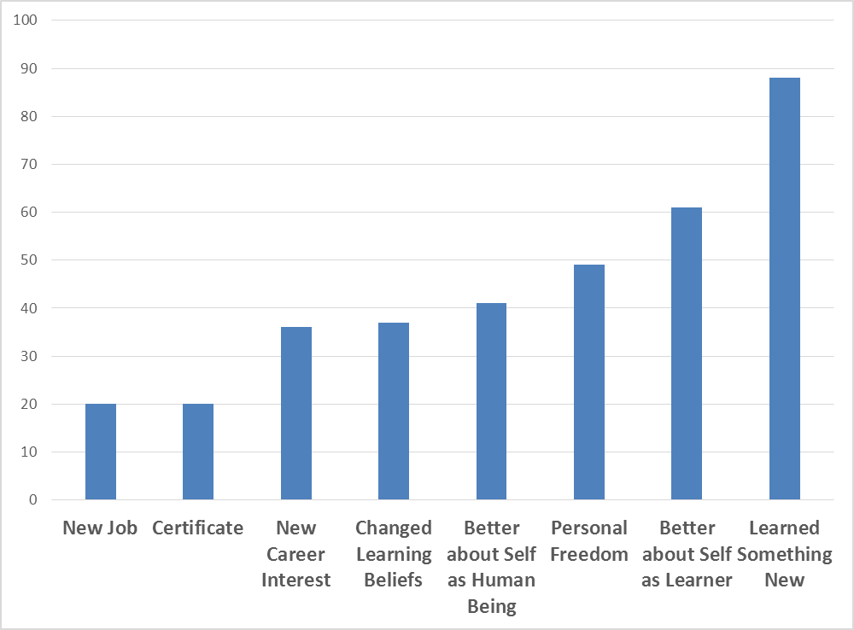
Figure 1. Achievements from informal learning pursuits.

As shown in Figure 2, intrinsic motivation trumped extrinsic. More specifically, curiosity, seeking information, self-improvement, and wanting to learn something were the key reasons to informally explore the Web to learn. In fact, nearly 70 percent had personal goals for self-improvement. More impressively, nearly 80% were simply interested in finding out about a particular topic (See Figure 2). More than half were doing so, at times, for professional development reasons.

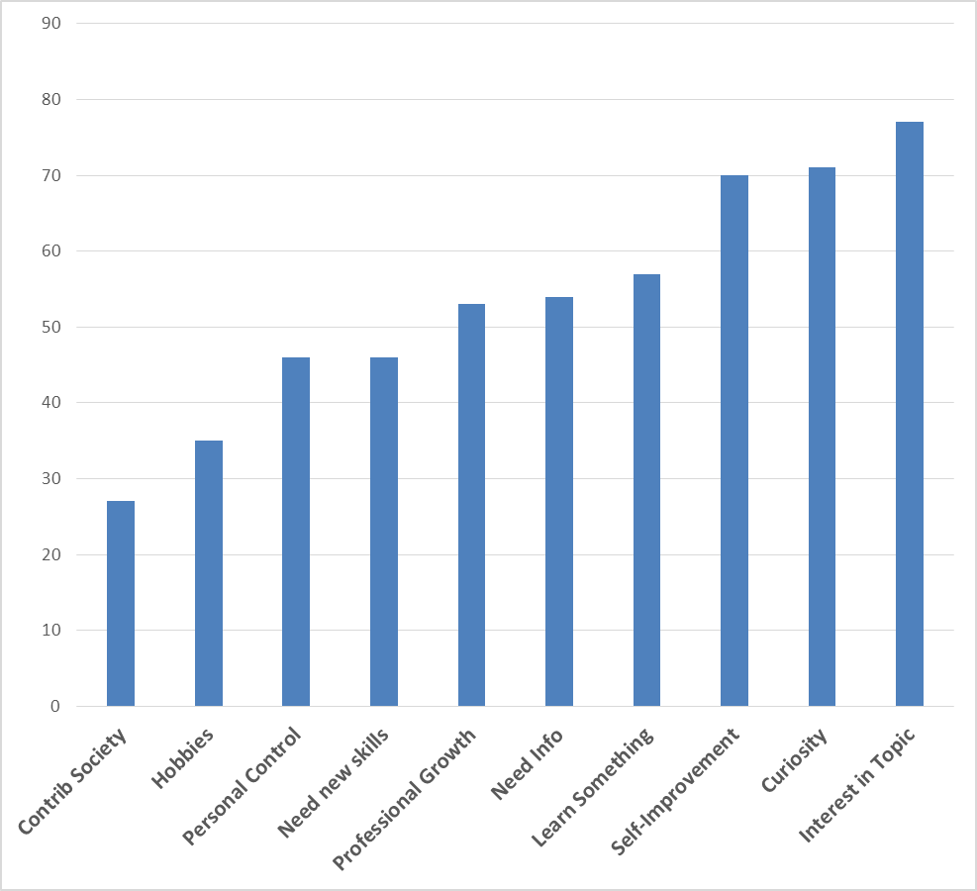
Figure 2. Main reasons to informally explore the Web to learn.

The researchers specifically asked about key factors that typically led to their online learning successes when engaging in informal online experiences (see Figure 3). Once again, freedom to learn was rated the highest (72%), followed by sense of resource abundance (47%), choice (44%), control over the activity or resource (41%), sense of fun (40%), and producing or creating something new (37%). Clearly, informal learners want the freedom to pick and choose what they want to learn. When the resource pool increases, so do the choices and opportunities for learner autonomy.

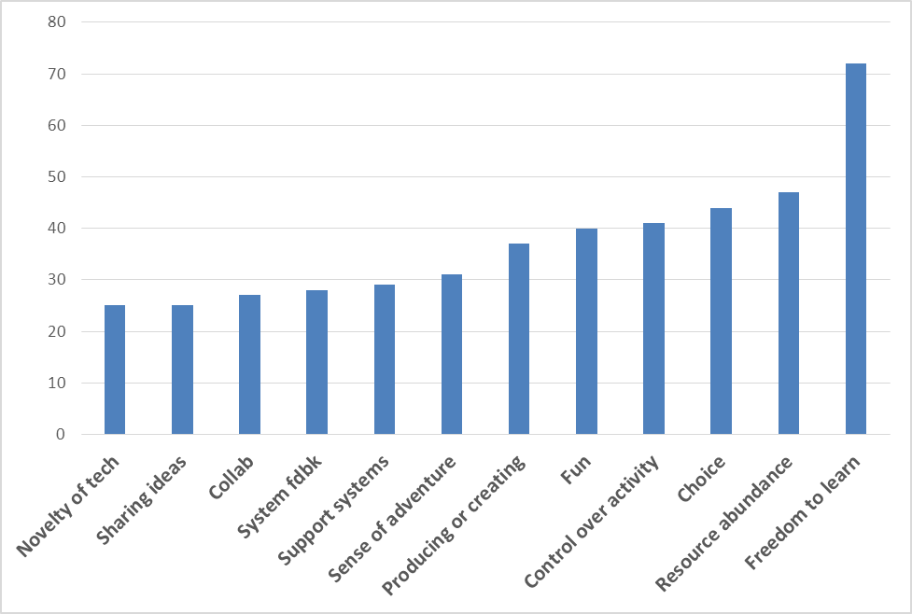
Figure 3. Factors leading to success or personal change what learning informally online.

Participants were asked what they would like to achieve from their informal learning endeavors (see Figure 5). While nearly 85% engaged in informal online learning for a new skill or competency, 57% were there to engage in a learning experience that would better their life. Some wanted to simple fix something at home (43 percent), whereas others had more grandiose goals of helping society (47 percent).
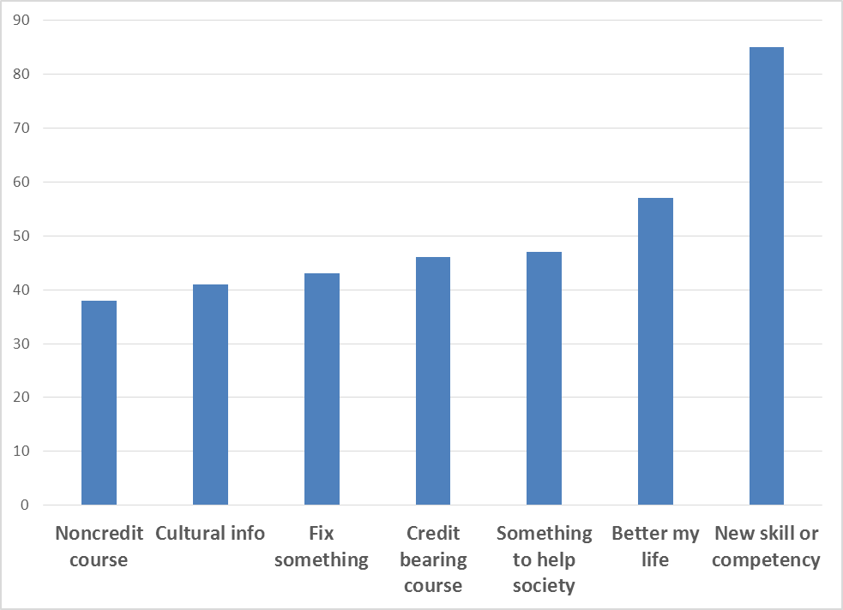
Figure 5. What would you like to achieve from informal learning online.

At the same time that many respondents noted their informal and self-directed learning successes, many others encountered significant obstacles. For instance, slightly under 20 percent noted a lack of access to the site or service or firewall barriers. Most significant was the lack of time to use (roughly 50 percent). Such time constraints are often noted by those enrolled in MOOCs and other time intensive online courses. Other issues might include the lack of support within one’s work environment for informal learning (17 percent), difficulty in using the site or service (23 percent), the lack of high quality open resources in a particular area (32 percent), and membership or technology fees (45 percent),
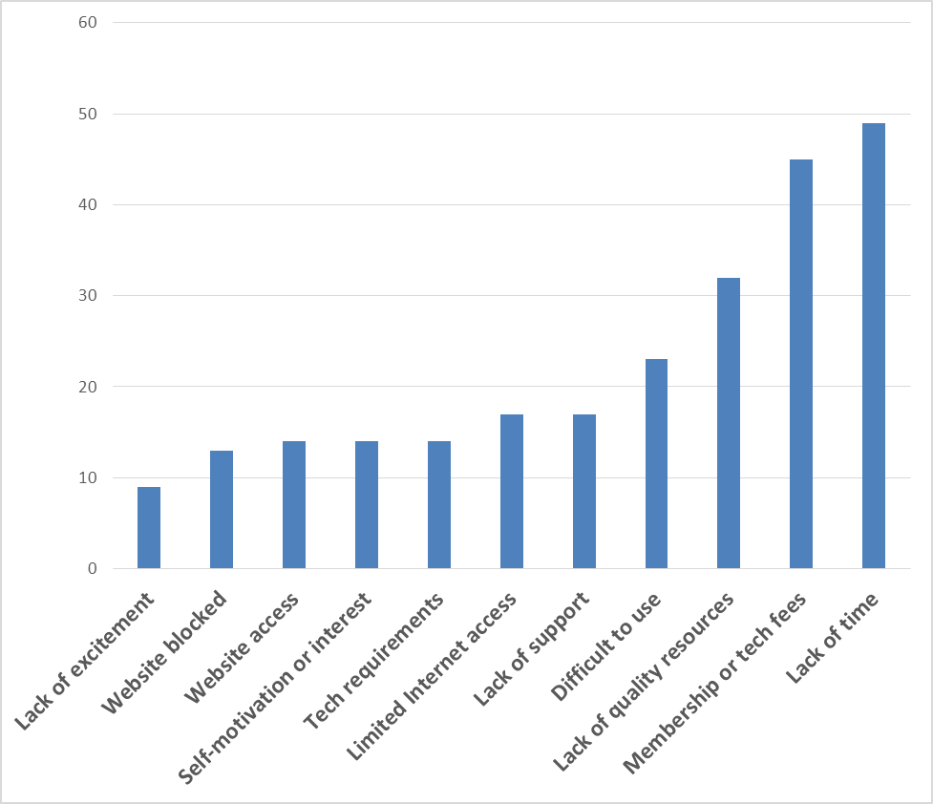
Figure 4. Obstacles and challenges faced when learning informally online.

The data reveal that learners felt some type of life change from their informal learning pursuits. In fact, more than 75 percent of the respondents felt a sense of life change.
Many of the above quantitative findings were elaborated on in the open-ended survey responses; some of which are recapped below.

Qualitative Findings: MOOC Participants
One way to understand the impact of OCW is to explore the qualitative data according to different age groups. There were numerous interesting stories of life change embedded in the data. Seven different ones are briefly detailed below based on age from teenage years to people now in retirement or starting new careers.
Case #1. 18-20 year old male from the Middle East.
Result. OCW inspires young people and can change entire educational systems.

When i was 14 years old i found MIT OCW during my search in..(physics) by Prof Walter Lewin looked really interesting and i became interested in physics. To be honest OCW changed my way of living and i found how beautiful physics is…informal learning is interesting because you can have access to some of the best courses provided by the best universities in the world…MIT OCW or Stanford open courses have also changed the educational system in some poor countries and have taught the teachers and professors in those countries how to teach a subject in a modern way.
As the quote above indicates, OCW developed for college students at MIT can be used by middle and high school students who normally would not have access to that information. Such materials can inspire young people into a career that they had not previously contemplated. They can also provide a sense of curiosity and wonder about a concept, theory, or entire discipline. Such individuals might become advocates for the field who encourage their peers to learn about the content area. At the same time, the online videos and other resources from inspirational and engaging instructors can offer those teaching a subject area without sufficient training to learn new skills and teaching techniques. As such, OCW impacts the entire learning environment. Informal learning can impact highly formal learning.
Case #2. 21-30 year old unemployed female from North America.
Result. OCW helps to become self-taught about social media.

At first my purpose was to fulfill boredom …After graduating with a MS, I was faced with unemployment. I took the opportunity to read blogs, watch Youtube videos, and more to learn about blogging and social media. Since then I have become well versed in social media and other business topics and started a business… I decided not to pursue a PHD because I am learning a more rapid pace. Instead of spending 5 years in school, I can be flexible and work on what I am learning.
Many young people today remain unemployed after obtaining a college degree and many more are uncertain about their future. As the quote above reveals, OER and OCW offer a chance to gain new knowledge and skills as needed without having to head back to college for a lengthy commitment such as pursuing a doctorate. Just-in-time learning available through blog posts, podcast shows, online news, open access research articles, and YouTube and other shared online video allows self-directed learners to learn at the time and place most appropriate. As noted above, such abundance of open resources can accelerate the learning process. And, at the same time, much money can be saved on tuition. Many years previous spent in school can now be reallocated in contributing to society. In addition, there is greater flexibility and convenience as to when and where learning occurs. If successful, one’s personal identity and self-esteem is enhanced.
Case #3: 31-40 year old male from Asia
Result. Self-Directed learning enhances current job prospects
I learnt scheme from MIT OCW. Which helped in learning elisp/lisp. The programming techniques increased my software design knowledge. Algebra - mit ocw course was very useful, it helped me to refresh the basics of Digital signal processing. - I have learnt a lot of "applying my knowledge" than just learning the "theory" - Various online classes allow for multiple perspectives of the same topic thus showing us how the same thing can be applied in different fields.
Revealed in the quote above is an obvious use of MIT OCW. People search for content online that can elevate their status in a present job situation. Skills inadequately learned or long forgotten can be relearned. In addition, cutting-edge content such as the latest in computer programming can be acquired as needed and immediately applied on the job. As such, the self-directed learner can test and continue to refine the newly formed skills. Importantly, theory can be linked to practice; instead of being disconnected. This individual also points out that with multiple courses available online on the same topic, he can integrate multiple perspectives or ways that instructors teach a given topic. When effective, his learning is richer and there are multiple paths for retrieval and use of their knowledge. In the end, he can obtain job security or even a raise or bonus for their knowledge.
Case #4. 41-50 year old male from the Middle East.
Result. Better prepared to reenter university life.
Most interesting experience of my own was my use of MIT OCW to refresh on Calculus. I purchased the textbook and followed one of several calculus options on the site. This was quite successful in re-introducing Calculus, as a prep to re-entering college 28 years after graduation - this time to study for a Master's.
Numerous reports speak to the need to have several different types of jobs during one’s career; often 7 or 8 different ones is noted. Often just one or two high quality learning experiences can help ready someone for a new post or job opportunity. The middle aged individual from the Middle East who is quoted above found his refresher course on Calculus to be an ideal course to prepare him for his upcoming enrollment in a master’s program. Interestingly, he points to several options that MIT OCW offered to learn Calculus; he was not restricted to one set path or set of course materials. Instead, he could pick and choose from several resources or courses. Such choice is highly motivational and can foster a greater sense of personalization of learning.
Case #5. 51-60 year old female from North America.
Result. Open educational resources and open access to people builds expertise and expert connections for a learning apprenticeship.

I'm a virtual reference librarian…My friend and I have a blog about music cognition, which is a little crazy because we don't know anything about it. Nevertheless, we blog about current articles, and one experience was especially meaningful, where I tweeted a question to Daniel Levitin, who answered. He's the guy who wrote The World in Six Songs, among other things. The fact that you can communicate with an expert in the field who will take the time to give a thoughtful tweeted (and yes, 140 characters can be thoughtful)--well, that's amazing…I think it was the single most exciting learning moment I've experienced.
Several things are interesting about this quote. First of all, this individual decided to create a new blog in an area in which she had limited skills and knowledge. Such a bold move might indicate that learning technologies like a blog can be the virtual napkin from which to explore one’s emerging ideas and interests. What is even more interesting is that she received guidance and support from an established musical performer. In effect, in a highly self-directed world, our teachers might be people we never have met; including some we never would have imagined would respond to our queries. Apprenticeship can come from anywhere. This individual definitely was delighted by this unexpected support. As such events occur, learner intrinsic motivation is peaked. It will be hard to slow down the momentum. The
Case #6. 65 year old male from North America
Result. A retiree develops a new hobby through OER and OCW and that hobby requires still more skill.

I retired from education I became a lifestyle entrepreneur. I was trying to learn software to develop a business website for our sailing business. I discovered…Lynda.com. I was learning web development, video editing and photoshop. I realized that I could learn this software without going to a formal class and that was an "eureka" moment.. My wife and I travelled and started a yacht delivery and training business that has taken us all over the world. We learned technology and social media as we travelled and ended up with many fantastic experienced in some very exotic places. We taught ourselves web development and have been figuring out online learning as we went. Now at 65 years of age we are going back to university to take a Computer Science Degree and start a new tech business relating to interactive educational media and games. All very exciting :-)
As with the second case, online courses and OER can equip a self-directed learner with timely skills to be a successful entrepreneur. In this case, however, it is not someone starting a new career, but, instead, a husband and wife team who are retired. Their learning of Web design and development as well as related skills has helped them develop a sailing business. They are so successful that they have decided to enroll in a university for a degree in computer science. In effect, their informal learning has been so fulfilling that they are enrolling in formal education. Importantly, they are able to balance their various online knowledge pursuits and their building of their new business. And he is doing so in his mid 60s. With OER and OCW, life never ends; instead, a series of life paths can unfold across the lifespan.
Case #7. 70+ year old female from North America.
Result. New Web design skills help a retiree showcase her talents.

I'm an avid photographer and have developed skills for developing my own website for display of my photography and books I have written that include my photographs…I've had multiple careers, from science, to public administration, and information technology. The development of my art is a new and exciting experience.
This final quote illustrates the use of OER and OCW across the lifespan. Those who retire or who pursue new hobbies need multiple access to learning. Free and open online courses or even just a few modules or learning contents from a course can provide the skills needed to run a business (e.g., learning about tax accounting) or to market or demonstrate one’s talents. The latter is definitely evident in this case. What is particularly interesting is that this 70+ year old is learning how to design on the Web from course contents found on the Web. Her art is a new career. With open educational materials, she can continue to develop those skills.

These seven individuals provide an important glimpse into the potential for life change from open educational resources. They each represented a different age group or generation. Importantly, all seven experienced something significant as a result of learning online. Clearly, OCW and OER can help in building, enhancing, or changing a career. Additional research is needed to ferret out the motivational components and support structures that can be embedded in open content to help larger numbers of people take advantage of open education.
Conclusions and Implications
It has been a little over a decade since Charles Vest’s courageous announcement about all courses from MIT being made available for free use online. The educational world has changed dramatically since that time. Not only are millions more people learning online in every educational sector—K-12, higher education, and corporate, military, and government training settings—but informal learning has simultaneously proliferated. The movement toward a more open educational system has shifted to highly massive endeavors that are prominent in the news such as MOOCs. The open educational world is discussed by educators, politicians, corporate executives, military leaders, and family members. As it rises in salience, most institutions of higher learning are deliberating on next steps. Some are struggling to come up with plans and solutions that incorporate open education.
The findings of this research offer new insights into the lives of individuals attempting to learn from free and open resources on the Web. There are myriad reasons why individuals around the world access OER, OCW, MOOCs, and other free and open educational resources to learn. As such resources proliferate, there are new opportunities for self-directed learners to explore, share, and obtain new skills and competencies. Most vital are not specific skills but the opportunities for life altering changes. Better understanding of the goals of these self-directed learners should help in the design of more engaging informal and extreme learning environments. Such information also might play a role in supporting people who presently are not self-directed learners.
In terms of content related successes, these learners amassed skills in physics, computer science, teaching, chemistry, business, law, and many other fields. They also learned through an assortment of online resources. Such self-directed learners rely on patience, flexibility, persistence, and sharing when using OER. Consequently, this research can inform us of their needs, beliefs, and experiences. These individuals discussed their new sense of freedom to learn. Many truly enjoy learning for the sake of learning, without any associated external reward or certificate of accomplishment. They explore personal interests and find what is meaningful to them.
While data analyses are ongoing, many of those we surveyed and interviewed felt a definite life change from free and open educational content. Some started a new business. A couple commented on how the skills they learned helped them to overcome huge problems as when a country imploded or was dramatically altered politically (e.g.. Russia). In contrast, several of the respondents noted that while they did not experience significant life changes, they were extremely happy to keep up with changes occurring around them. Others felt that changes were more incremental than suddenly life changing. Still others felt momentous life change in the form of newly discovered freedom to learn, autonomy, and a sense of Eureka as well as greater confidence, happiness, and inspiration. For most, open education offered a sense of accomplishment that was not possible in traditional educational settings.

Future Directions
As a society that is shifting resources toward more free and open contents, there is a pressing need to understand how to foster self-directed learning from OER. First the characteristics of self-directed learners need to be better understood. Second, as these traits are uncovered, there might be training programs created as well as self-directed learning supports or scaffolds that might be embedded in OER or MOOCs at key moments in the learning process or available upon demand.
What those supports might look like is still unknown. What is certain, however, is that education is changing. Online and blended learning are disruptive forces that are shaking up traditional brick and mortar environments (Christensen, Horn, & Staker, 2013). Now add OER and MOOCs to the mix, and the waves of disruption seem to appear each day. New educational innovations will undoubtedly arise in the coming decade. Charles Vest ushered in this new century with his bold proclamation. He certainly will not be the last.

References
Atkins, D., Brown, J. S., & Hammond, A. (2007, February). A review of the open educational resources (OER) movement: Achievements, challenges, new opportunities. William and Flora Hewlett Foundation. (84 pages). Retrieved from http://www.hewlett.org/uploads/files/ReviewoftheOERMovement.pdf
Bonk, C. J. (2009, October 19). The wide open learning world: Sea, land, and ice views. Association for Learning Technology (ALT) Online Newsletter, Issue 17. Retrieved February 22, 2013, from http://archive.alt.ac.uk/newsletter.alt.ac.uk/newsletter.alt.ac.uk/1h7kpy8fa5s.html
Bonk, C. J. (2011). YouTube anchors and enders: The use of shared online video content as a macrocontext for learning. Asia-Pacific Collaborative Education Journal, 7(1). Retrieved from http://www.acecjournal.org/2009/Journal_Data/Vol7No1/201103.pdf

Christensen, C., Horn, M. B., & Staker, H. (2013, May). Is K-12 blended learning disruptive: An introduction of the theory of hybrids. The Clayton Christensen Institute for Disruptive Innovation. Retrieved from http://www.christenseninstitute.org/wp-content/uploads/2013/05/Is-K-12-Blended-Learning-Disruptive.pdf
Downes, S. (2007). Models for sustainable open educational resources. Interdisciplinary Journal of Knowledge and Learning Objects, 3. Retrieved from http://ijklo.org/Volume3/IJKLOv3p029-044Downes.pdf
Iiyoshi, T., & Kumar, M. S. V. (2008). Opening up education: The collective advancement of education through open technology, open content, and open knowledge. Cambridge, MA: MIT Press. Retrieved November 27, 2011, from http://mitpress.mit.edu/catalog/item/default.asp?ttype=2&tid=11309&mode=toc
Jung, E., Kim, M., Wang, Y., & Bonk, C. J. (2011, October). What technology tools promote such extreme learning? Analysis of technologies used in extreme learning Websites. Proceedings of the E-Learn Conference 2011—World Conference on E-Learning in Corporate, Government, Healthcare, and Higher Education. Honolulu, Hawaii (pp. 2581-2587), Chesapeake, VA: AACE.
Kenning, C. (2012). For Knox soldiers earn deployed degrees. Courier-Journal. Retrieved from http://www.courier-journal.com/article/20120605/NEWS01/306050003/Fort-Knox-soldiers-earn-deployed-degrees
Millard, E. (2011, March). Going the distance. University Business. pp. 34-36, 38-39. Retrieved from http://www.universitybusiness.com/article/going-distance
Rivard, R. (2013, June 5). How to provide open access. Inside Higher Education. Retrieved from http://www.insidehighered.com/news/2013/06/05/publishers-universities-both-prep-open-access-plans
Stansbury, M. (2013, February 15). New ed-tech bill supports digital learning, Common Core. eSchool News. Retrieved from http://www.eschoolnews.com/2013/02/15/new-ed-tech-bill-supports-digital-learning-common-core/print/
Vest, C. (2001, April 4). MIT to make nearly all course materials available free on the World Wide Web. MIT News. Retrieved from http://web.mit.edu/newsoffice/2001/ocw.html

