Part 1: Updated “PEERS” Framework
Quality Control for Self-Published TEC-VARIETY book
Free Book: http://tec-variety.com/
Free Chapters: http://tec-variety.com/freestuff.php
Amazon CreateSpace: https://www.createspace.com/
Curt Bonk, Professor, Indiana University, cjbonk@indiana.edu
November 4, 2016

The PEERS framework was used for the book (free in English and Chinese):
Bonk, C. J., & Khoo, E. (2014). Adding Some TEC-VARIETY: 100+ Activities for Motivating and Retaining Learners Online. OpenWorldBooks.com and Amazon CreateSpace. Note: Free eBook available at: http://tec-variety.com/; Paperback http://www.amazon.com/dp/1496162722/ and Kindle http://www.amazon.com/dp/B00KJ1FAC8 versions; (Hardcover: by request).

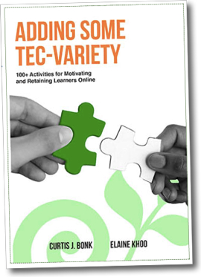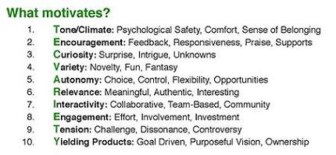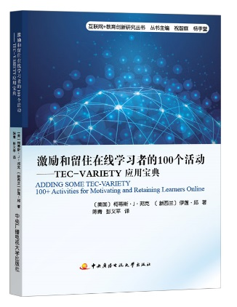

PEERS Framework (for review of a self-published book):
- Peer Review: Three e-learning and educational technology experts were hired to review the entire book during the summer of 2013 (admittedly, however, this was not a blind review). The authors made their changes and sent the revised manuscript to the copyeditor. In addition, the copyeditor also took on a role of editor throughout the process and made some solid suggestions on deletions, modifications, combinations, additions, etc.
- Extensive Planning and Pilot Testing: The book 14 years to plan, 7 years to collect articles, and 3 years to write. In addition, the framework in the book was discussed to large as well as a small audiences at conferences, workshops, institutes, summits, webinars, university classes, etc., for more than a decade. Tens of thousands of people attended those talks. Feedback was received from hundreds, if not thousands, of such people during that time.
- Expert Team Approach: As with all book publishers, we contracted with many experts to produce a book of the highest quality. We hired editors, copyeditors, research assistants, website developers, proofreaders, graphic artists, illustrators, indexers, formatters, converters to other formats (e.g., Kindle, hardcover, etc.), computer programmers, book publishers, consultants, etc. Each were paid a fee (not cheap). We also talked about the process with several others who had self-published a book in the past.
- Relied on Format of Proven Book: Most importantly, the “Adding Some TEC-VARIETY” book followed the exact same format as the “Empowering Online Learning: 100+ Activities for Reading, Reflecting, Displaying, and Doing” book which was published in 2008 by Jossey-Bass. In effect, the format works and was deemed to be high quality by a major publisher. And unlike many such activities books, this is a theory to practice book with not just 100+ activities but with extensive references and theoretical backing. Moreover, this book had the exact same first author as that book who went through the same writing process this time. As with the earlier book, he partnered with an expert to co-author it.
- Sharing Samples: Sample chapters were sent to other experts in the field and other interested scholars, educators, and researchers for the past three years as were the chapter resources, tools references, and citations. Everything was shared as much as possible. The feedback that was received helped us fine tune each chapter.
Part 2: The Pros and Cons of Self-Publishing
Curt Bonk, Professor, Indiana University, cjbonk@indiana.edu
November 4, 2016

Here is a list 10 advantages and 10 disadvantages of a free self-published book.

Advantages of Self-Publishing:
- Impact: Life impact. The ideas in the book related to teaching and learning can impact others around the world. And perhaps there will be some life impact or personal change from a few of them. There is also the potential for curriculum impact, resource impact, innovation impact, etc.
- Longevity: Longevity of ideas. Someone could find or use or modify this book long after the authors are gone. Digital archivists and educators might stumble upon this book centuries from now.
- Rural and Disadvantaged: A free book helps people in the developing world learn new content. In addition, teachers and course designers can ramp up online and blended course development.
- Control: This IS the big one. The authors can design and change things how they want. Use the book titles and subtitles that they want and the examples that they want. And, yes, 2-3 experts peer reviewed the book just like another publisher (e.g., Jossey-Bass/Wiley) would have done.
- Experiment: It is an experiment. The authors can learn what works. We can practice marketing skills. We can share with others about self-publishing. We can start OpenWorldBooks.com. And we can continue the experiment with the next book.
- Less to Pack: Less guilt when someone has a request or when you visit a country with no gifts. I can always give people this book (or at least the link to download it).
- Fun and Novel Invitations: The authors can trade book royalties for interviews, discussions, invited panels, consultations, and speaking invites.
- Parting or Meeting Gift: It is something the authors can give to students, guests, and visiting scholars. I can send to anyone who visits or calls to interview me on the phone.
- Growing Network: The network of contacts around the world expands.
- Reputation: It brings attention to author reputation or brand and everything else that one does.

Negatives in Self-Publishing:
- Personal Time and Effort: This project has been my baby for a long time. And I made it free? This was not just 3 years in the making. I had an IST master’s student collect articles 7 years before completion. And Vanessa Dennen and I discussed a possible book on online motivation 14 years prior.
- Cost: The authors spent much out of pocket money designing and developing this book. Proofreaders, researcher assistant, Web designer and programmer, copy editor, editors, indexer, formatter, graphic designer, publisher, and website costs. It was not insignificant (I’m happy to share the costs via email).
- Potential for Failure and Looking Foolish: It could backfire and no one could find out about the book. If that happens, one could look foolish.
- Perceptions of Self-Published Book: People might think that it is low quality since it is being given away for free. The author reputation could take a hit. Some scholars/academics might look down on someone who self-publishes.
- Piracy and Plagiarism Battles and Legal Fees: People could more easily plagiarize this book. They could copy it, sell it, and post it online. There could be many moles to whack via attorney letters.
- Fairness to Self (i.e., potential for psychological and physical problems): My body could tell me that I am an idiot after expanding so much energy to get this far and not get much in return.
- Fairness to Co-Author: My book writing colleague, Dr. Elaine Khoo, deserves some remuneration.
- Translation Negotiations: The authors have to negotiate book translations rights and contracts, instead of the publisher. Tough decisions have to be made about selling the book in another language or offering only free versions. It takes time to produce a new version of the book.
- Marketing and Dissemination Requirements: The authors have many ways to market the book with organizations that have hundreds of thousands of connections; however, they will lack the connections and networks of a major publisher (e.g., conference exhibits, newsletters, Website promotions, etc.).
- Future Expectations: In the future, how can the authors justify charging a fee for any book that takes less than 14 years to produce?

