Pre-session Activity at Fort Sill
Professor Curt Bonk
(Warm-Up: Think Back and Think Ahead)

- Jot down and share with neighbor what, if anything, do you remember from Dr. Bonk’s presentations last August?

Topics he discussed:
- the use of shared online video;
- critical and creative thinking as well as teamwork with technology;
- blended learning models and activities;
- his R2D2 model for diverse learner needs (see back page for hints);
- his TEC-VARIETY motivational framework (see back page for hints);
- open education, MOOCs, and the World is Open book.

- Have you ever flipped your training or classroom instruction by having your students watch online video (i.e., lecture) content or listen to a podcast prior to coming to class? If yes, how or in what subject areas? Jot down ideas and share…

1. R2D2 (Read, Reflect, Display, and Do) Reminder.
Do you need to fly to a distant galaxy to use the ideas from this session? What is one Web resource, tool, or activity that you remember from this session or that you now use?

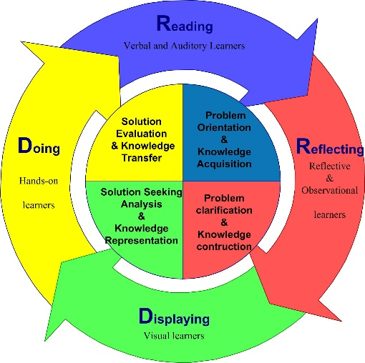
2. TEC-VARIETY Reminder. What motivational principles will you now try to use in your teaching or training?

What motivates?
Tone/Climate: Psychological Safety, Comfort, Sense of Belonging
Encouragement: Feedback, Responsiveness, Praise, Supports
Curiosity: Surprise, Intrigue, Unknowns
Variety: Novelty, Fun, Fantasy
Autonomy: Choice, Control, Flexibility, Opportunities
Relevance: Meaningful, Authentic, Interesting
Interactivity: Collaborative, Team-Based, Community
Engagement: Effort, Involvement, Investment
Tension: Challenge, Dissonance, Controversy
Yielding Products: Goal Driven, Purposeful Vision, Ownership

3. Shared Online Video Reminder: In what topics or subjects areas might you use shared online video? How are you or others at Fort Sill currently using shared online video (e.g., YouTube, YouTubeEDU, CNN video, BBC News and Video, TED talks, TEDEd, ForaTV, BookTV, etc.) in training sessions or courses? If so, what worked the best or was the most successful, if any?

Who wants to come to the front of the room and show something that they now use? What new tools or resources do you want to demonstrate?

