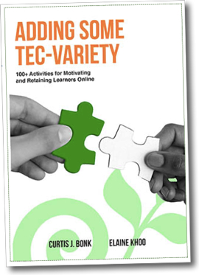
Adding Some TEC-VARIETY:
100+ Activities for Motivating and Retaining Learners Online

Bonk, C. J., & Khoo, E. (2014). Adding Some TEC-VARIETY: 100+ Activities for Motivating and Retaining Learners Online. OpenWorldBooks.com and Amazon CreateSpace.
Cover Design: Alex Bonk

Adding Some TEC-VARIETY helps instructors focus on how to motivate online learners and increase learner retention. It also is a comprehensive, one-stop toolkit for online instructors to inspire learners and renew their own passion for teaching. Using 10 theoretically driven and proven motivational principles, TEC-VARIETY offers over 100 practical yet innovative ideas based on decades of author experience teaching in a variety of educational settings.

What motivates?
- Tone/Climate: Psych Safety, Comfort, Sense of Belonging
- Encouragement: Feedback, Responsive, Praise, Supports
- Curiosity: Surprise, Intrigue, Unknowns
- Variety: Novelty, Fun, Fantasy
- Autonomy: Choice, Control, Flexibility, Opportunities
- Relevance: Meaningful, Authentic, Interesting
- Interactivity: Collaborative, Team-Based, Community
- Engagement: Effort, Involvement, Investment
- Tension: Challenge, Dissonance, Controversy
- Yielding Products: Goal Driven, Purposeful Vision, Ownership

In this book, you will discover:
- A wellspring of Web resources;
- 10 fully documented successful motivational principles;
- Hundreds of activities to motivate and engage online learners;
- Proven ideas on how to design interactive and collaborative courses;
- A realistic path toward meaningful and relevant online learning;
- Detailed risk, cost, and time guidelines for each activity;
- A thoroughly researched basis for each idea and activity;
- Hope (yes, real hope!) for engaging online learners.

About the Authors
- Curtis J. Bonk, is Professor at Indiana University teaching psychology and technology courses. Drawing on his background as a corporate controller, CPA, educational psychologist, and instructional technologist, Bonk offers unique insights into the intersection of business, education, psychology, and technology in his popular blog, TravelinEdMan. In addition to many national and statewide innovative distance teaching awards, since 2012 to 2018, Bonk has been annually named by Education Next and listed in Education Week among the top contributors to the public debate about education from more than 20,000 university-based academics. He has authored The World Is Open, Empowering Online Learning, The Handbook of Blended Learning, Electronic Collaborators, and, most recently, MOOCs and Open Education Around the World (http://www.moocsbook.com/).

- Elaine Khoo is a senior research fellow at the Wilf Malcolm Institute of Educational Research, Faculty of Education, University of Waikato, New Zealand. She obtained her doctorate in education from the same university and her master's in psychology with a focus on Cognitive Science from Vanderbilt University. Elaine researches effective digital pedagogies in online and blended learning contexts, learning communities, and participatory learning cultures. She has led and been involved in a number of funded research projects across early childhood, schooling and tertiary learning environments.

TEC-VARIETY Book Homepage: http://tec-variety.com/
Individual Chapters and Entire Book (FREE): http://tec-variety.com/freestuff.php
Amazon (paperback and Kindle): http://www.amazon.com/dp/1496162722/

