Monday November 2nd Colloquium Reminder (PDF, HTML):

Invite to talk: If you are interested in task-based experiential learning, authentic tasks, design-based research, online learning, MOOCs, open education, the World Health Organization (WHO), or taking a bus ride in Turkey, you might want to attend the following session:

Developing Online Experiential Learning through Educational Design Research

Thomas C. Reeves, Ph.D.
Professor Emeritus of Learning, Design, and Technology
The University of Georgia

Room Location: Wright, School of Education: Room 2140
Date: Monday November 2, 2015
Time: 2:00-3:00 pm (*See note on bonus session and book giveaway at the bottom)
Livestreaming URL: http://www.indiana.edu/~video/stream/liveflash.html?filename=Tom_Reeves_Colloquium
Archive URL: http://www.indiana.edu/~video/stream/launchflash.html?folder=video&filename=Tom_Reeves_Colloquium_20151102.mp4

Optional Web Conferencing Participation:
Web browser: https://bridge.iu.edu (Conference ID to dial: 233222878)

Talk Abstract:
This presentation will describe how the World Health Organization took an award-winning experiential learning course that takes place on a bus traveling down the “cold chain” for time- and temperature-sensitive pharmaceutical products in Turkey, and moved it online as an award-winning authentic tasks-based experiential learning environment. This conversion was driven by the application of educational design research (also known as design-based research). Similarities and differences in the objectives of the two courses as well as of the learning activities, tools, and technologies deployed in two courses will be illustrated. The presentation concludes with examples of design principles that can be applied to the design of other online experiential learning environments.

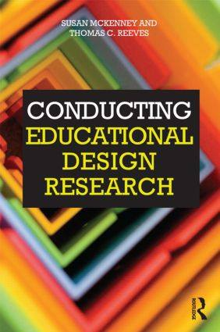

Thomas C. Reeves, PhD (Tom) is Professor Emeritus of Learning, Design, and Technology in the College of Education at The University of Georgia. Before moving to Georgia, he held positions at the Medical University of South Carolina and the University of Maryland. He is former Fulbright Lecturer in Peru and he has been an invited speaker in the USA and many other countries. In 1995, he was selected as one of the “Top 100” people in multimedia by Multimedia Producer magazine, and from 1997-2000, he was the editor of the Journal of Interactive Learning Research. In 2003, he received the Fellowship Award from the Association for the Advancement of Computing in Education (AACE), in 2010 he was made a Fellow of the Australasian Society for Computers in Learning in Tertiary Education (ASCILITE), and in 2013 he received the Lifetime Award from the International Association for Development of the Information Society (IADIS) as well as the David H. Jonassen Excellence in Research Award from the Association for Educational Communications and Technology (AECT). His books include Interactive Learning Systems Evaluation (with John Hedberg), a Guide to Authentic ELearning (with Jan Herrington and Ron Oliver), Conducting Educational Design Research (with Susan McKenney), and MOOCs and Open Education Around the World (with Curt Bonk, Mimi Lee, and Tom Reynolds). He currently serves as a consultant for the World Health Organization on the development of authentic task-based e-learning for public health personnel involved in pharmaceutical cold chain management as well as for other clients on the design and evaluation of serious games and simulations for healthcare personnel, first responders, and others. For more info: http://www.evaluateitnow.com/

Bonus Session (and book giveaway): 3:00-3:30 pm (same day)
Immediately after this talk, Dr. Reeves and IU Professor Curt Bonk will briefly discuss their newly edited book with Routledge, “MOOCs and Open Education Around the World” as well as their special journal issue on this topic. Each were published in early July 2015. Professors Reeves and Bonk will give away signed copies of their book to anyone who comes to the extra session and asks a question. For more on these books, see: http://moocsbook.com/. Don’t miss this chance for a free book.

