Early Career Symposium 2019 Agenda, Monday, October 21
Convention Center, Pavilion 3, 4:30-5:30 pm
Creating Space for Academic Writing:
Glimpses into the Digital Writer’s Desk

Brief Session Presenter Bios:
- Susie Gronseth is Clinical Associate Professor in the Learning, Design, and Technology program at the University of Houston (UH). She may be contacted at slgronse@Central.UH.EDU.
- Elizabeth (Betsy) Dalton is adjunct professor for the Communicative Disorders Department at the University of Rhode Island. She may be contacted at elizabethmdalton@gmail.com.
- Ke Zhang is Professor in the Learning Design and Technology Program at Wayne State University in the USA. Inquiries are welcome by email to ke.zhang@wayne.edu.
- Curtis J. Bonk is Professor at Indiana University teaching psychology and technology courses. He can be contacted at cjbonk@indiana.edu and his homepage is at http://curtbonk.com/.
- Thomas C. Reeves is Professor Emeritus of Learning, Design, and Technology at The University of Georgia. He can be reached at treeves@uga.edu and his homepage can be found at http://www.evaluateitnow.com/.
- Thomas H. Reynolds is a Professor of Teacher Education at National University in La Jolla, California. He can be contacted at treynold@nu.edu.
- Mimi Miyoung Lee is Professor in the Department of Curriculum and Instruction at the University of Houston (UH). She may be contacted at mlee7@uh.edu.

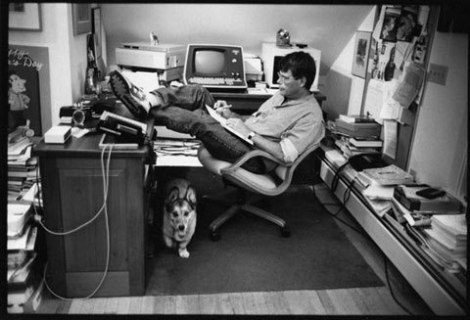

Early Career Symposium 2019 Agenda, Monday, October 21
Changes to Your Writing Space

Great Ideas | Idea or Suggestion | How might you use or operationalize it?
Idea #1.
Idea #2.
Idea #3.
Idea #4.
Idea #5.
Idea #6.
Idea #7.
Idea #8.
Idea #9.
Idea #10.

Possible Writing Space Changes or Modifications…
#1.
#2.
#3.
#4.
#5.

