Stand Up and Shine-Share-Show
Professor Curt Bonk (End of Day)

Masterclass Part 4. Engage, Number One: This is the Next Generation (Adding Some Jumbo Motivation with the TEC-VARIETY Framework)
- SS#1: Stand Up and Shine with R2D2 (Read, Reflect, Display, and Do). Do you need to fly to a distant galaxy to use the ideas from this session? What is one Web resource, tool, or activity mentioned that you can use.

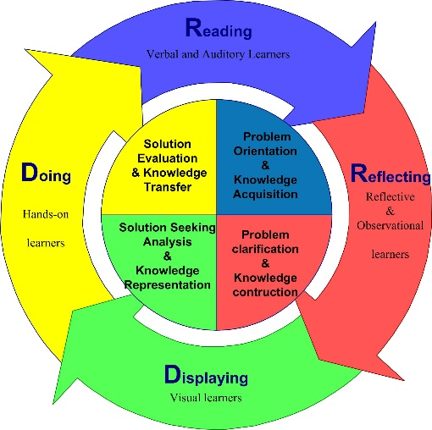

- SS#2: Stand Up and Share with TEC-VARIETY. What motivational principles will you now try to use in your teaching? In what topics or subjects areas might you use the TEC-VARIETY framework?

What motivates?
Tone/Climate: Psychological Safety, Comfort, Sense of Belonging
Encouragement: Feedback, Responsiveness, Praise, Supports
Curiosity: Surprise, Intrigue, Unknowns
Variety: Novelty, Fun, Fantasy
Autonomy: Choice, Control, Flexibility, Opportunities
Relevance: Meaningful, Authentic, Interesting
Interactivity: Collaborative, Team-Based, Community
Engagement: Effort, Involvement, Investment
Tension: Challenge, Dissonance, Controversy
Yielding Products: Goal Driven, Purposeful Vision, Ownership

- SS#3: Stand and Show (demonstrate). Who wants to come to the front of the room and show something that they will use? What new tools or resources do you want to demonstrate?

