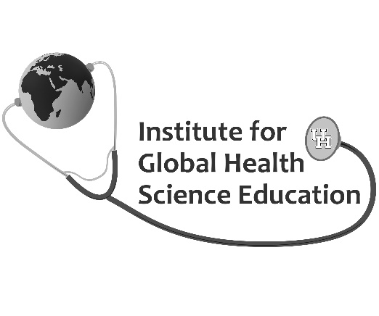
Distinguished Speaker Series
Friday, February 14, 2020
KIVA, Farish Hall, University of Houston

8:30 am Continental Breakfast

9:00 am Welcome

9:15-10:15 am Meaningful Heath Science Instruction in the Digital Age: When Evolution Stumbles into a Revolution
Dr. Curt Bonk, IST Professor, Indiana University

10:15 Break

10:30-11:30 am The Transformational Potential of Education Design Research
Dr. Thomas C. Reeves, Professor Emeritus, University of Georgia

11:30 am - 12:00 pm Break and transition to lunch (box lunches set up outside KIVA)

12-1:00 pm Transforming Instruction into Scholarship
Dr. Teri Turner, Director, Center for Research, Innovation, and Scholarship, Texas Childrens’ Hospital

1:00-1:15 pm Break and transition to Masterclasses

1:15-2:15 pm Masterclass (Choose 1)
- Ultra-Engaging Learning With Technology: Introducing the TEC-VARIETY and R2D2 Models
Dr. Curt Bonk, IST Professor, Indiana University
- Learning Activities for Health Science Educators: A Fun Exercise
Dr. Thomas C. Reeves, Professor Emeritus, University of Georgia

2:15-2:30 pm Break

2:30-3:30 pm Masterclass (Choose 1)
- Ultra-Engaging Online, Blended, and FTF Learning: 50 Low Risk, Low Cost, Low Time Strategies
Dr. Curt Bonk, IST Professor, Indiana University
- Learning Activities for Health Science Educators: A Fun Exercise (Repeat)
Dr. Thomas C. Reeves, Professor Emeritus, University of Georgia

3:30-4:00 pm Final thoughts (KIVA)

