Brain Expander Side One
Two Models of Technology Integration:
Adding Some “TEC-VARIETY”
Curt Bonk, Indiana University, June 7, 2019 at JHU
 | Ideas Definitely Can Use | Ideas Might Use | Ideas Can’t Use | Questions and Comments
- Tone and Climate
- Encouragement and Feedback
- Curiosity and Intrigue
- Variety and Novelty
- Autonomy and Choice
- Relevance, Meaningful, Authentic, and Interesting |  |  |  | 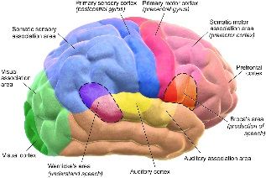
- Interactive and Collaborative
- Engagement and Involvement
- Tension and Challenge
- Yielding Products, Goals, and Purpose
Brain Expander Side Two 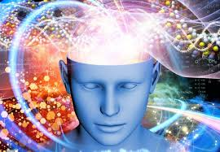
Two Models of Technology Integration:
Where are you “R2D2?”
Curt Bonk, Indiana University, June 7, 2019 at JHU
 | Ideas Definitely Can Use | Ideas Might Use | Ideas Can’t Use | Questions and Comments
- Read
- Reflect
- Display
- Do
Across Phases

